SERVLET EXERCISES

Exercise 1: Create the HTML file, named Exercise1.html and servlet file execute the requests from HTML file.
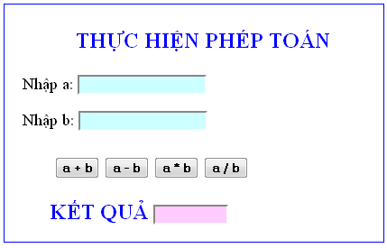
Exercise 2: Create the HTML file, named Exercise2.html and servlet file execute the requests from HTML file.
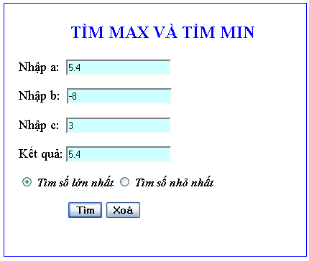

Exercise 3: Create the HTML file, named Exercise3.html and servlet file execute the requests from HTML file.

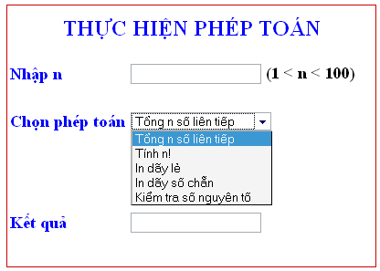

Exercise 4: Create the HTML file, named Exercise4.html and servlet file execute the requests from HTML file.

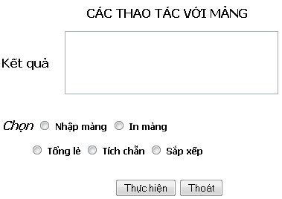

Exercise 5: Create the HTML file, named Exercise5.html and servlet file execute the requests from HTML file.

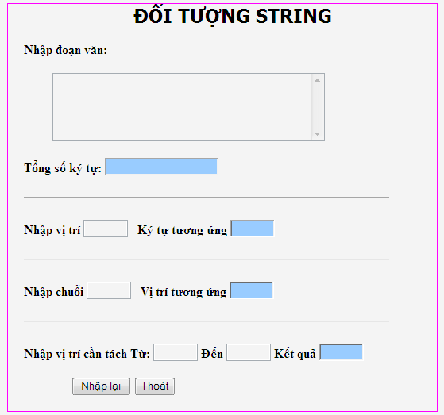

Exercise 6: Solve the equation: ax + b=0;
